How to Book Transavia from Availability– Clue card
Galileo Smartpoint 5.1 onwards

Look for neutral or carrier specific display Availability | A14JULAMSBCN  A14JULAMSBCN+18JUL (SMARTPOINT ONLY)  A14JULAMSBCN*HV | HV – Transavia  TO – Transavia France
Book required class | 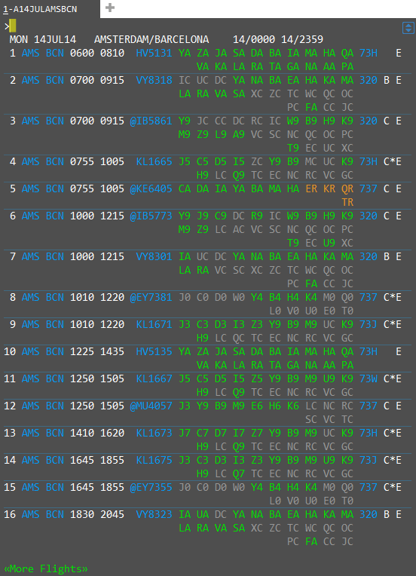  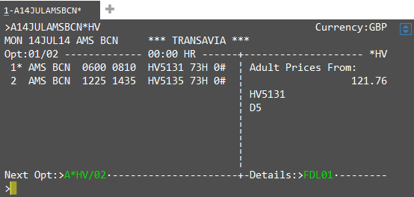  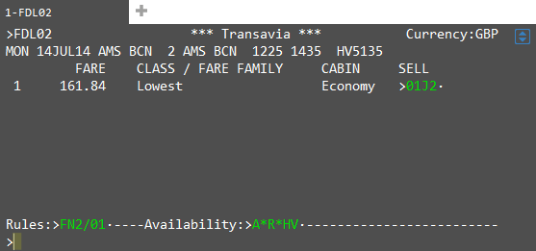 | N1Y1 or from Smartpoint neutral availability clicking on the class will do a direct sell.  Please see separate clue card for booking from a Fare Shopping workflow  To select a different itinerary option from carrier specific availability, Click on or TAB to >A*HV/02 to move to option 2 then click on or TAB to Details:>FDL02 to see the cost breakdown for all booking classes.  From the details page, click on or tab to any of the sell options to sell the required class >01J2  Flight segments will be returned to the PNR with a ZK status.  The entire booking takes place via the airlines API and therefore the active segments reside with the direct payment carrier and not in the GDS.  The ZK status code is for direct payment carriers only.
Enter mandatory passenger information | N.TEST/JADEMRS  T.T*  W. or D.  MT. or MF.  P.  SI.P1/SSRDOCSHVHK1////GB/12JUL76/F//TEST/JADE  R. | 5 Fields required for the address including country and post code *P/  Date of birth and Nationality are required to end booking (Use Current GDS Formats for SSRDOCS)
Fare Quote Booking | FQ  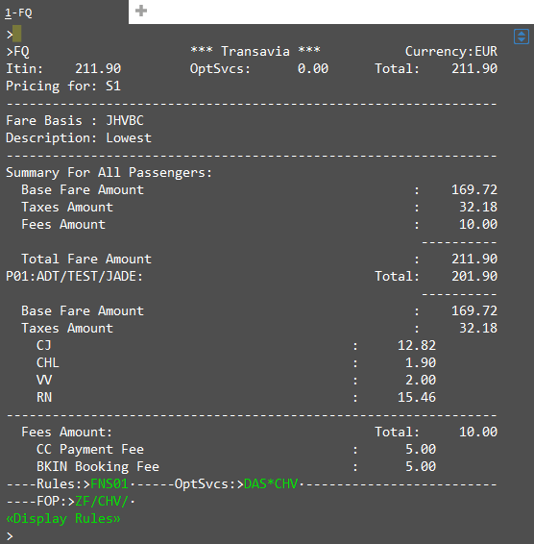 | If you have scheduled carrier segments in your PNR you will need to quote the Transavia segments individually i.e. FQSx (x= Segment number)
Selling ancillaries | Click on or TAB to DAS*Cxx (xx=Direct Payment Carrier)
To sell a bag/sport equipment | Make sure “*” is next to the service required :  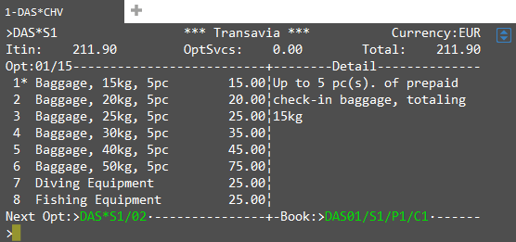  Then TAB to Book: >DAS01/S1/P1/C1  Count added to the detail screen:  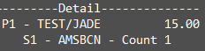 | C1 = to number of bags required, Count 1  Any ancillaries added to the reservation will be added to the running total within the FQ under OptSvcs
To display seat map | SA*S1  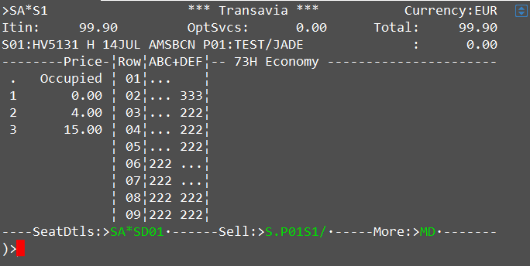 | Please note the booking file has to be priced before trying to display a seat map
To sell a seat from the seat map | TAB to Sell:>S.P01S1/  Indicate from the seat map which seat is required, and enter it after the “/” or tab stop and hit “Enter”  Response on the details screen:  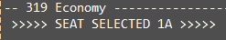 | Please note the number in the seat map represents a price i.e. 2D costs EUR15.00  The prices are detailed in the legend on the left hand side.  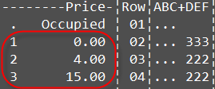
To Pay for and complete booking | ZF* to display payment options  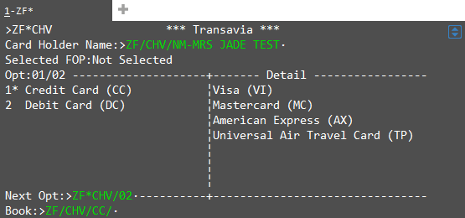  Tab to book and add credit card information  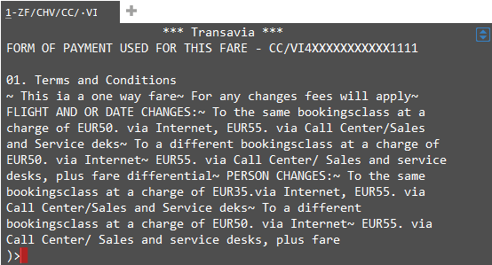  Now enter ER  Galileo Reference returned and the Transavia vendor locator under *VL. To display the booking in the Transavia system enter Z*R/CHV  When a direct payment carrier reservation is completed, document itinerary (DI) remarks will be created within the PNR to be passed to Mid/Back office. | Please note credit card information will come across from the FOP line if present. You can override by typing new credit card details.  The Transavia confirmation will be emailed to the email address in the MT or MF field.

For further information please see ASK Travelport, Travelport Aggregated Shopping User Guide, Answer ID AN9274

